**Day-3 Assignment**

**Step 1:** Creating an author component

app>mytraining>components>right click>create node>author

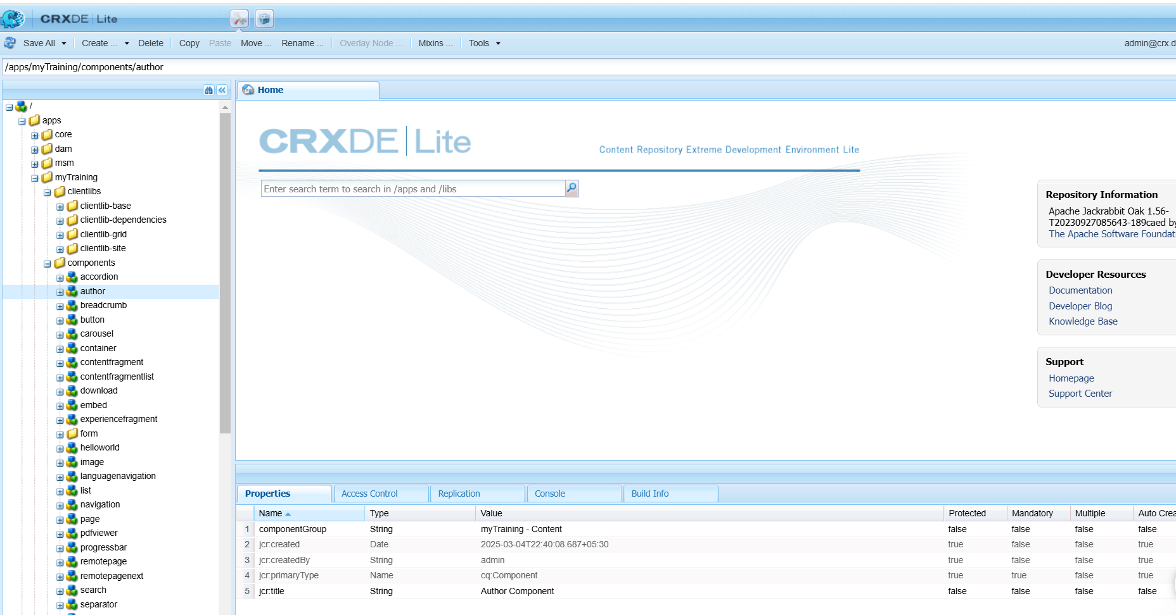

**Step 2:** Creating author.html file and cq:dialog under author

author>right click>create file>author.html

author>right click>create node>cq:dialog

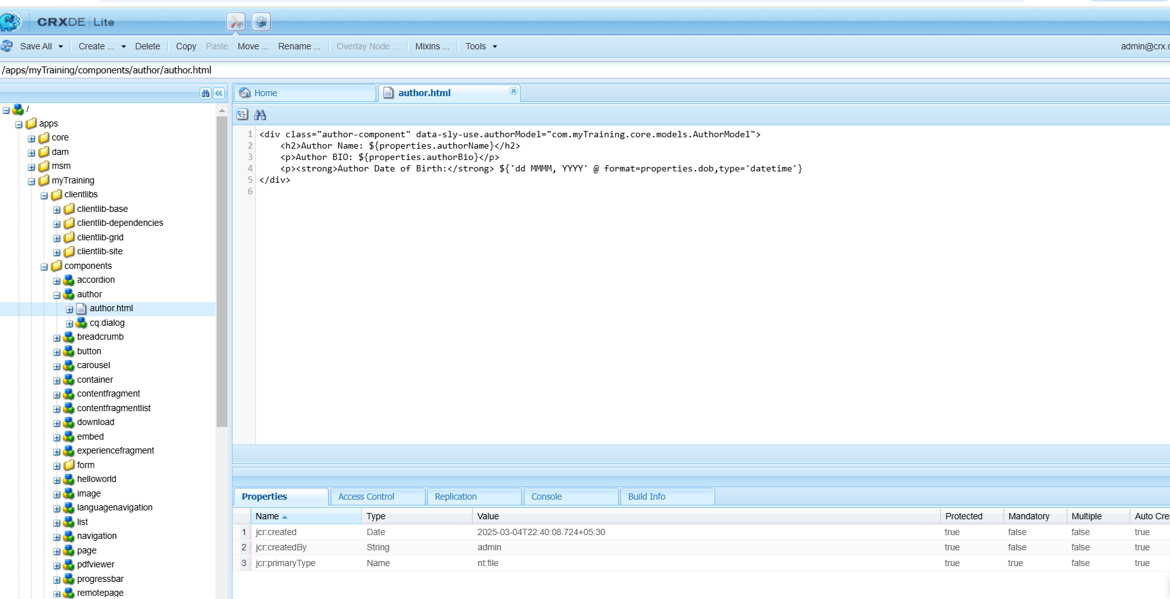

**Step 3:** Creating content node inside dialog to create the fields required.

author>cq:dialog>right click>create node>content

content>right click>create node>items

items>right click>create node>columns

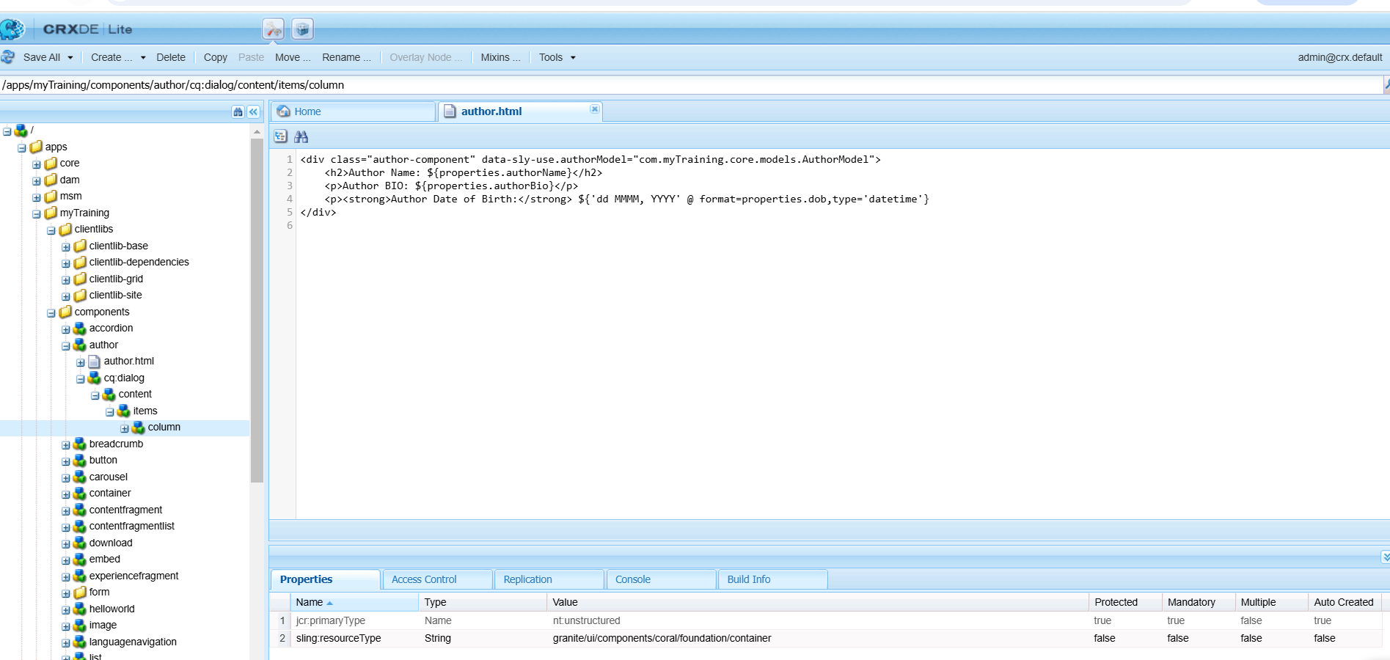

**Step 4:** Creating “items” again under “column” for briefly differentiating the item fields. Now adding the 3 required fields which are author name , author bio , dob

column>right click>items

items>create node>authorName

items>create node>authorBio

items>create node>dob

and adding required properties to the fields

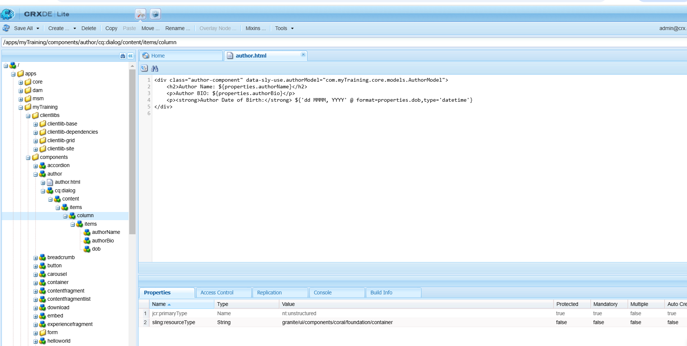

**Step 5:** Adding clientlibs

apps>mytraining>content>auhtor>right click>new node>clientlib

clientlib>right click>new file>css.txt

clientlibs>right click>new file>author.css

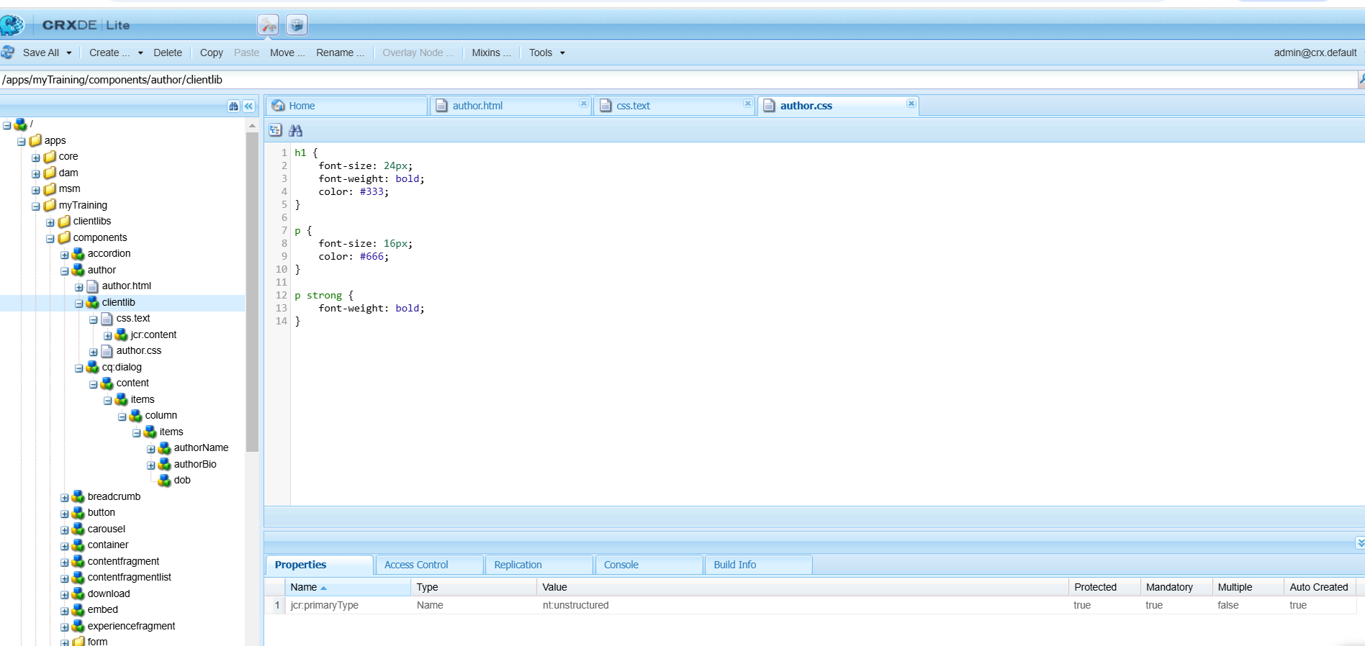

**Step 6:** Understanding extra clientlibs. Adding extraClientlibs for reference

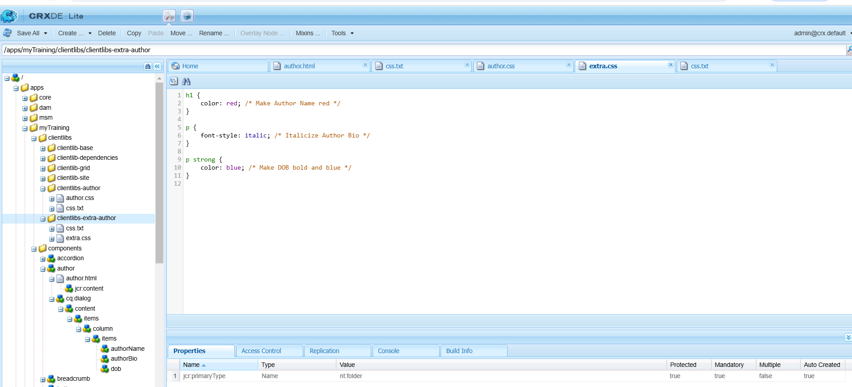

**Step 7 :** Dragging the author component in AEM editor page

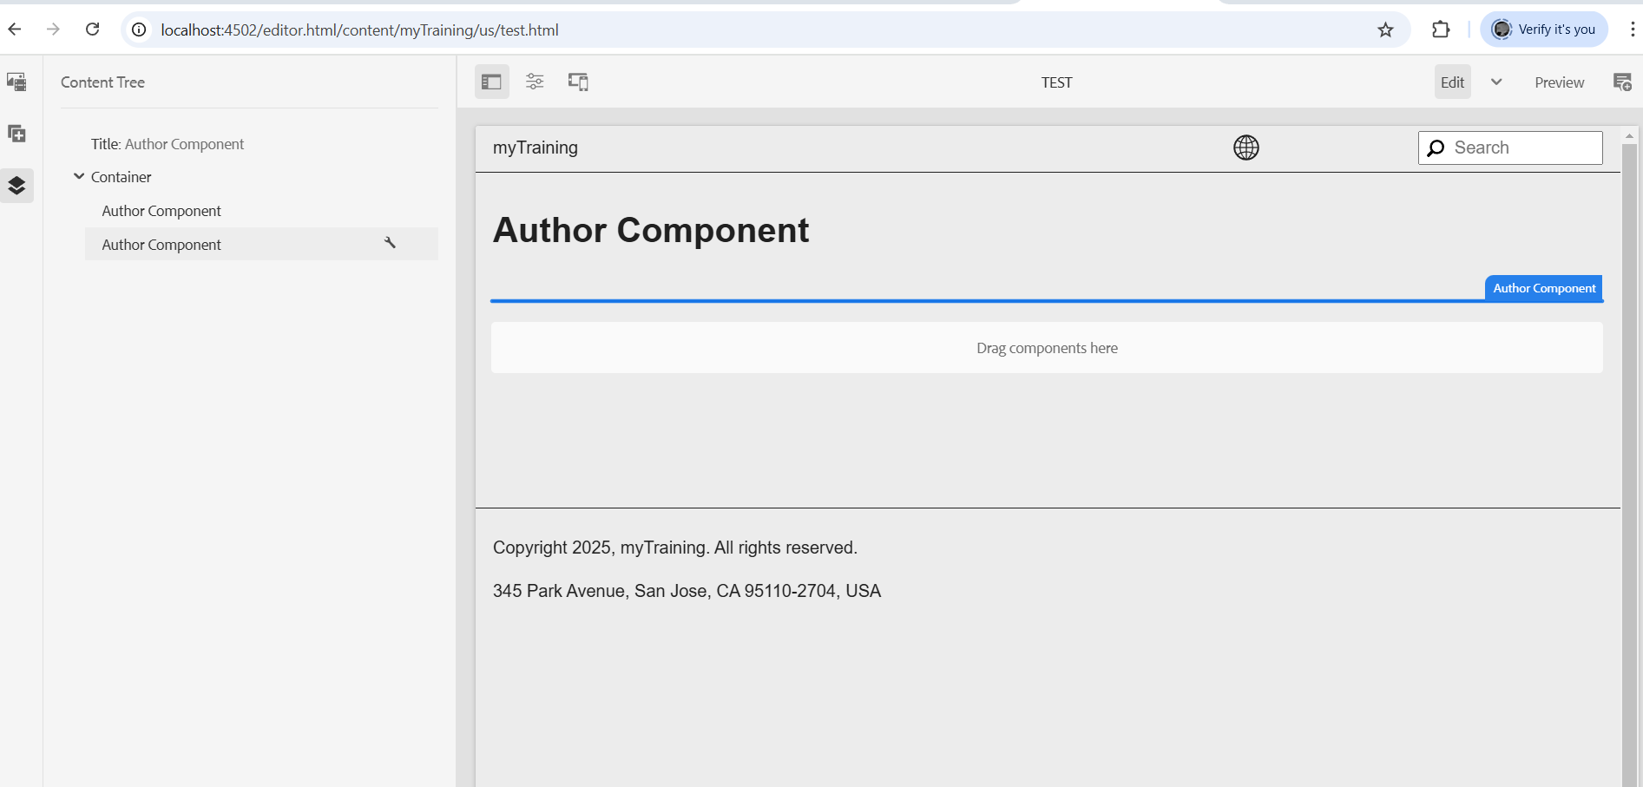

**Step 8:** Adding details

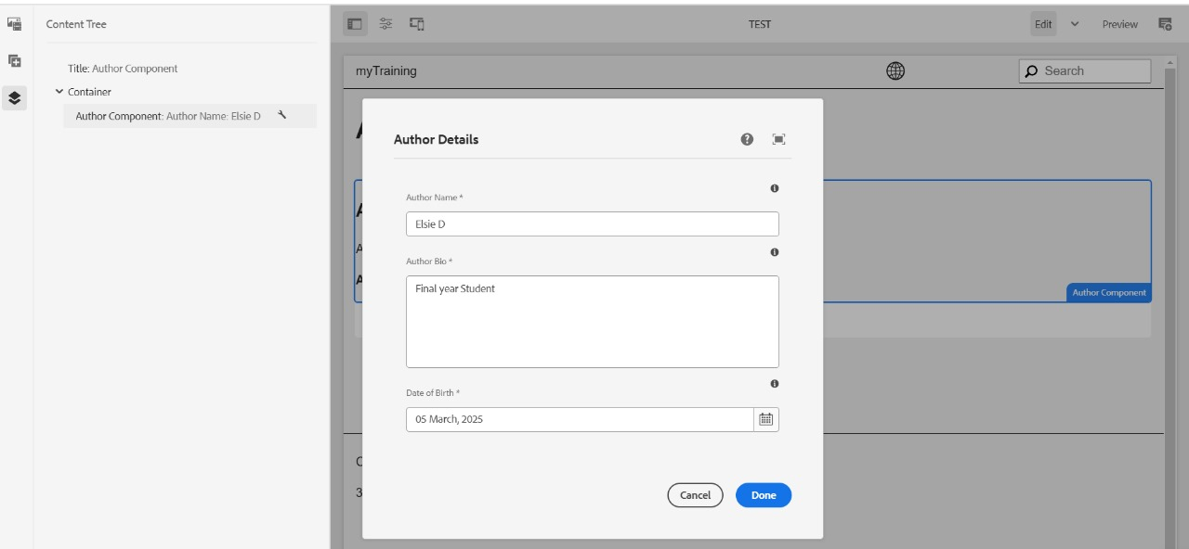

**Step 9: Final Output**

